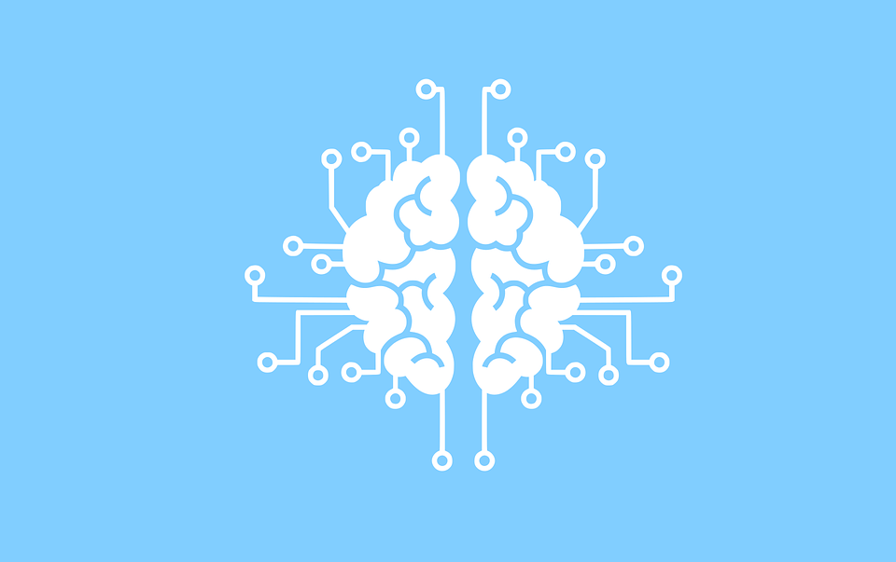

The Intro ML Course

Prerequisites -

* Basic Knowledge in a programming language, preferably python,
* Good Understanding of maths,
* analytical skills

1. What is AI, machine learning, deep learning , data science (0.2 hr)
2. Should you learn ML? (0.1 hr)
3. Supervised, Unsupervised, Reinforcement learning (0.5 hr)
4. Using jupyter notebooks and colab (0.5 hr)
5. Libraries - numpy, pandas, matplotlib, sklearn (1 hr)
6. Linear regression, Logistic regression, (2.5 - 3 hr)
7. Intro to Unsupervised learning → K-Means clustering(1 hr)
8. How to do projects.

Page break image